Point-in-Time Recovery

]# mysqlbinlog /var/lib/mysql/mysql-bin.00001 (To read this binary log)
Position no is after at ‘xxxxxx’
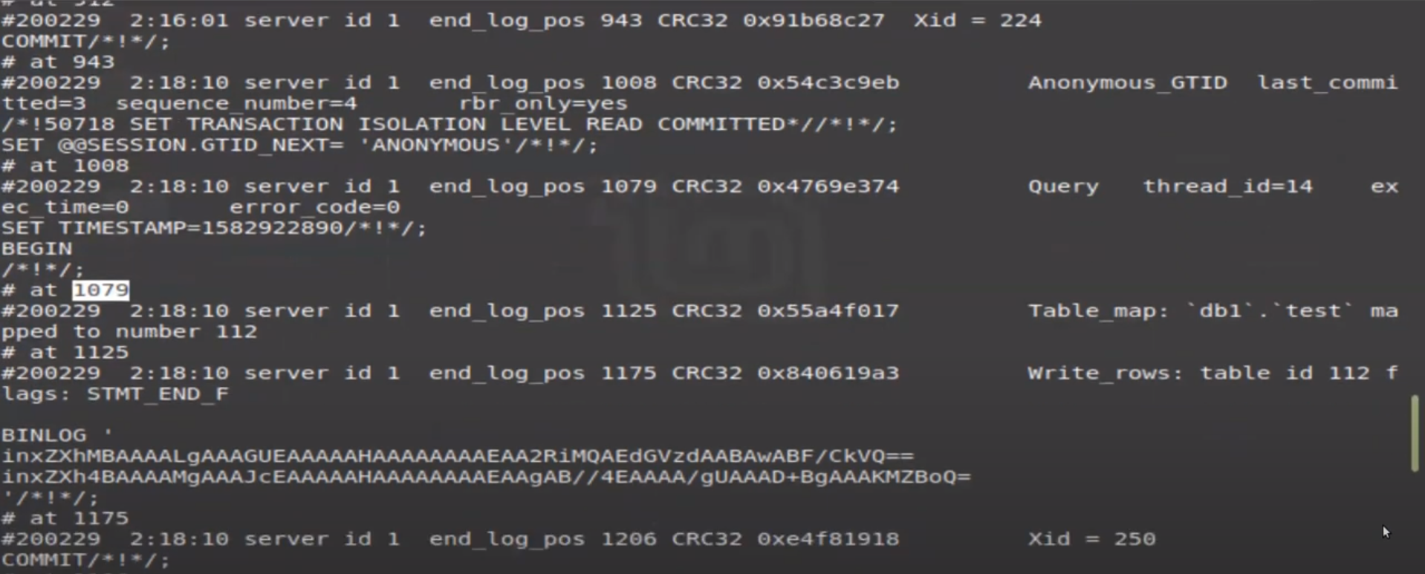

To take binary log recovery use below command
]# mysqlbinlog /var/lib/mysql/mysql-bin.00001 --start -positions 1079 --stop -positions 1342 - - skip- gtids > /backup/binlog.sql
(here we get recovery file then just import/restore the data)
Mysql> source /backup/binlog.sql

############################# Point in time recovery ################################
binary logging
The binary log contains “events” that describe database changes such as table creation operations or changes to table data.
mysql> show variables like 'log_bin%';
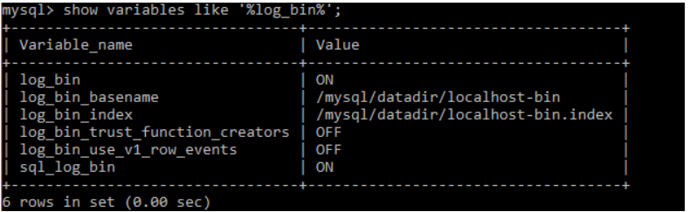

To Read the binary log file if we simply cat log (not possibale)
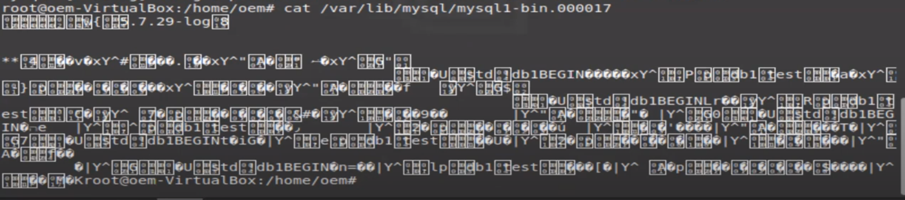

mysql> SHOW BINARY LOGS; (To see location of bin log)
mysql> SHOW MASTER STATUS; (To see current binary log)

]# mysqlbinlog /var/lib/mysql/mysql-bin.00001 (To read this binary log)
Position no is after at ‘xxxxxx’

To take binary log recovery use below command
]# mysqlbinlog /var/lib/mysql/mysql-bin.00001 --start -positions 1079 --stop -positions 1342 - - skip- gtids > /backup/binlog.sql
(here we get recovery file then just import/restore the data)
Mysql> source /backup/binlog.sql

Scenario
Recover data before the drop database.
]# Cat db1.sql | grep “change master” (backup taken file name)
----- change master to master_log_file= ‘binlog.0012” , master_log_pos= 254215319; (it can show their backup which binlog file generated and master log pos show starting position of that backup in log file.)

we check is that statment present in that bin log file or not
]# mysqlbinlog -v binlog.0012 | grep -i "drop database prod" (prod=database name)

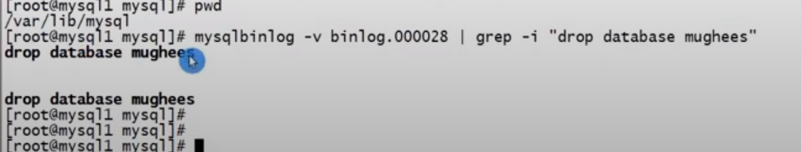

or pager grep -A 1 -B 2 'PROD' | grep -B 4 droop
show binlog events in 'binlog.0012';
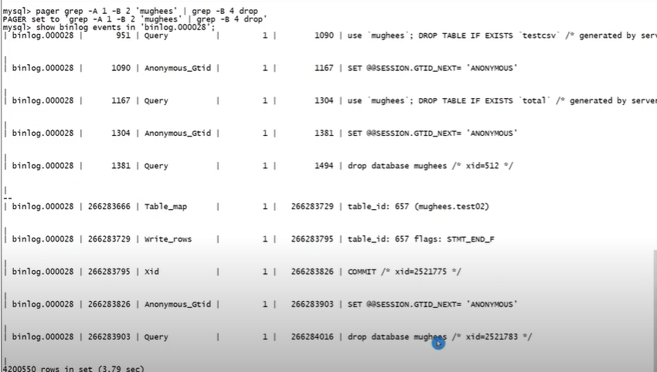

] # mysqlbinlog -v /var/lib/mysql/binlog.0012 > master.txt

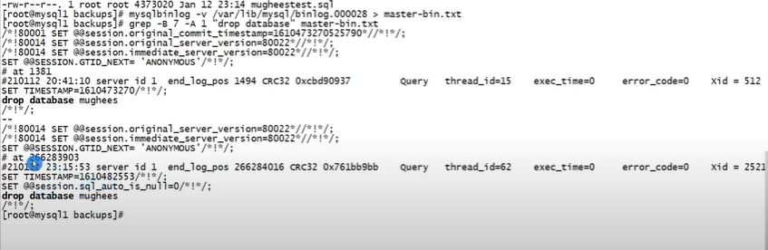
restore
$ mysqlbinlog --start poisition xxxxxx --end poisition xxxxxx /var/lib/mysql/binlog.0012 | mysql
Or

$ mysqlbinlog --start poisition xxxxxx --end poisition xxxxxx /var/lib/mysql/binlog.0012 > data.sql
Mysql> source data.sql

$$$$$ if you have more then one binlog file then
ex binlog.0012
binlog.0013
binlog.0014
binlog.0015
binlog.0016
(at first binlog their is start position and at last binlog is end poisition or before drop database statement)

mysqlbinlog --start poisition xxxxxx /var/lib/mysql/binlog.0012 | mysql
mysqlbinlog /var/lib/mysql/binlog.0013 /var/lib/mysql/binlog.0014 /var/lib/mysql/binlog.0015 | mysql
mysqlbinlog --stop poisition xxxxxx /var/lib/mysql/binlog.0016 | mysql

